**OUTPUT OF ASSIGNMENT 3B**

**INITIAL: NO DATA**

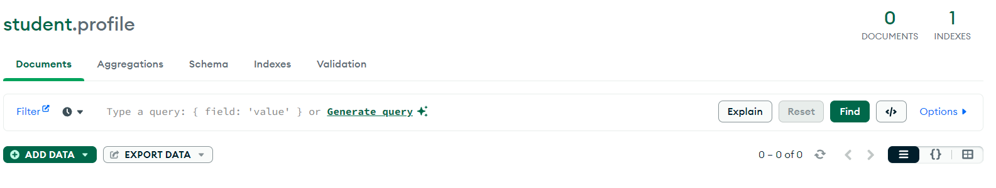

1. **API FUNCTION: CREATE – POST FUNCTION**

**CURL COMMAND AND CONFIRMATION**

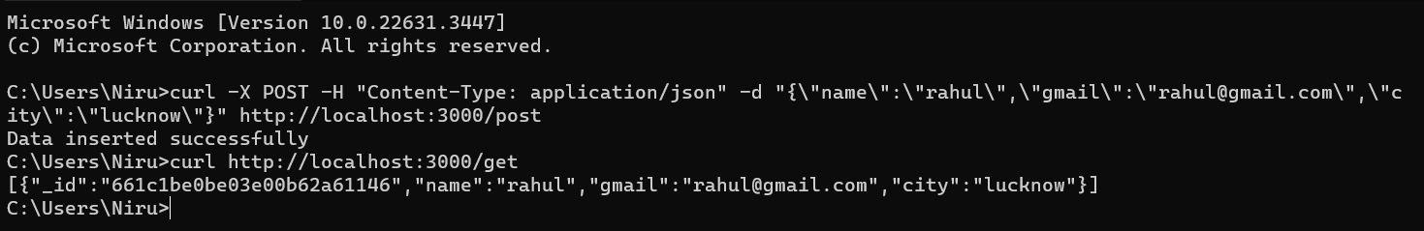

**CONFIRMATION THROUGH COMPASS UI**

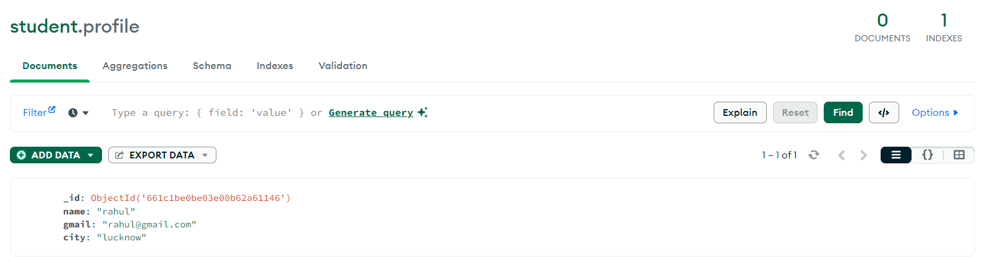

1. **API FUNCTION: RETRIEVE- GET FUNCTION**

**CURL COMMAND:**



1. **API FUNCTION: UPDATE- PUT FUNCTION**

**CURL COMMAND AND CONFIRMATION**

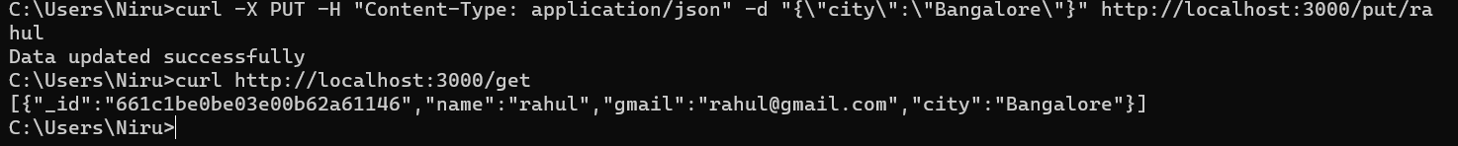

**CONFIRMATION THROUGH COMPASS UI:**

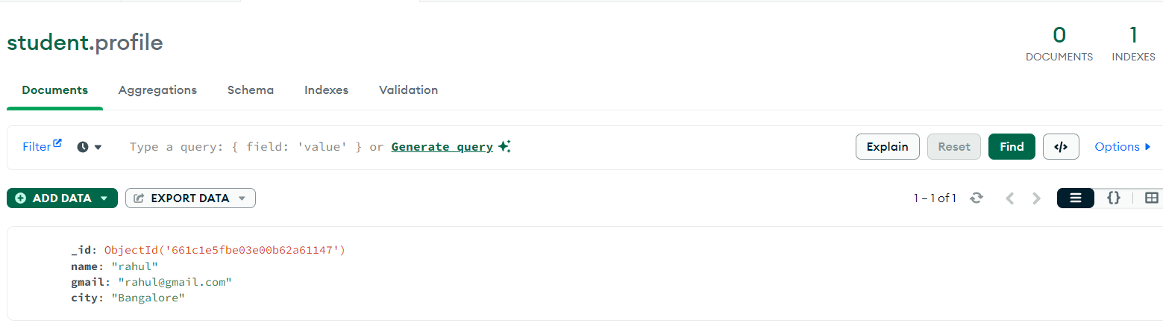

1. **API FUNCTION: DELETE FUNCTION**

**CURL COMMAND AND CONFIRMATION**

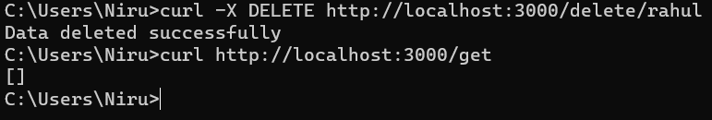

**CONFIRMATION THROUGH COMPASS UI:**

